Question Paper Generator
Use Case Document


 | Prepared By / Last Updated By | Reviewed by | Approved By
Name | Aakash Thakur  Bharat Singh  Deepak Singh  Harshita Trivedi  Rajat Kapoor | Anita Rananaware
Role | Team Member | Trainer
Signature
Date

Table of Contents
1.0 Introduction 3
1.1 Purpose & Scope of the document 3
1.2 Intended Audience 3
1.3 Use case ‘User Registration’ 3
1.3.1 Use case attributes 3
1.3.2 Use Case Model 4
1.3.3 Business Rules 4
1.3.4 UI Requirements 4
1.3.5 UI Field Validations 5
1.4 Use case ‘User Credential Authentication’ 6
1.4.1 Use case attributes 6
1.4.2 Use Case Model 7
1.4.3 Business Rules 7
1.4.4 UI Requirements 7
2.0 Database Design 8
2.1 Tables Structure 8
3.0 Change Log 10

Introduction

Purpose & Scope of the document
- Providing the necessary inputs to the detailed requirements gathering phase and further on for the SDLC processes.

- This document also serves to establish the traceability between the Business Objectives and the requirements identified in the proposed solution and how they satisfy the stated objectives.
- Provide expectation traceability in terms of the requirements and the user expectation.
- Serves as a formal template for documenting the Business Requirements which also includes statutory and regulatory requirements.
The purpose of this document is to systematically capture requirements for the project and the system to be developed. Functional requirements are captured in this document. It also serves as the input for the project scoping.

Intended Audience
- All members of the project.
- Delivery assurance/excellence group.

Use case ‘User Registration’

Use case attributes
Use Case Description:

This use case deals with the capture of user details. The ‘user’ here shall be the operator of the system and will be keying in the student information into the system.

Scope:

- User registration

Actors:

- User – the operator

Trigger:

Click ‘Save’ button in the ‘User Registration’ page

Pre-Condition:

User being able to access the homepage & get redirected to the ‘User Registration’ page upon click of ‘Sign Up’ Button.

Post Condition:

User is in the enrollment page & submit details

Flow of Events:

User at homepage → Click ‘Register’( if new’ )Button → User is in the enrollment page → User details are submitted and added onto the database

Primary Scenario:
A new user – is able to click ‘Sign up’ button and able to provide his details and get enrolled in the system.

Use Case Model
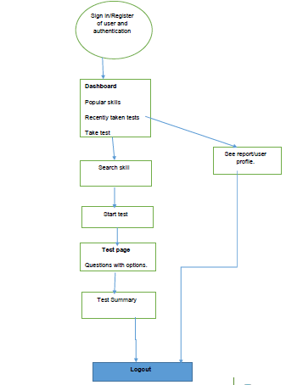

Business Rules

Business rules should be defined using the following attributes: -

- When the user clicks on the Signup link, it should re-direct to registration form.
    - User needs to fill some of the basic attributes/fields as mentioned below in requirement: First Name, Last Name, Email id, Password, Confirm Password.
- Clicking ‘Submit’ should validate the datatype constraints for each field
- Post-successful field level validation, save the information in the database.
- Upon saving the information in the database, display the message ‘User Registered successfully’.

UI Requirements
Here is a prototype on how the homepage should look like.



Here is a prototype on how the ‘User Registration’ page should look like.

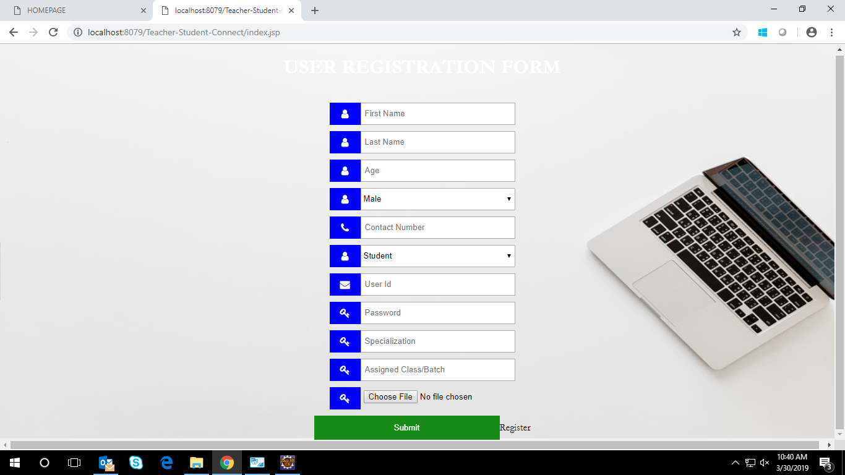

UI Field Validations
Please refer to the below requirements for field level validations:

- All fields are mandatory and if user fails to provide information on the mandatory fields it will show an alert.
- Username should be less than 50 chars.
- Password and Confirm Password fields should be the same.
- First Name, Last Name, Email should be less than 50 chars.
- Password must be combination of letter, digit and special character.

Use case ‘User Credential Authentication’

Use case attributes
Use Case Description:

This use case deals with the authentication of the user credentials. The ‘user’ here shall be the operator of the system and will be keying in the student information into the system.

Scope:

- User credentials authentication

Actors:

User – the operator

Trigger:

Click ‘Login’ Button, after keying in ‘User ID’ & ‘Password’ field.

Pre-Condition:

User being able to access the homepage

Post Condition:

User is in the Student Registration page

Flow of Events:

User at homepage → Key in ‘UserID’ & ‘Password’ field → User credentials are validated → Student Registration page is displayed

Primary Scenario:
A registered user – is able click ‘Login’ Button, after keying in ‘UserID’ & ‘Password’ field and get his credentials authenticated with the existing database entry.

Alternative Scenario:
A registered user – is able click ‘Login’ Button, after keying in ‘UserID’ & ‘Password’ field and unable to get his credentials authenticated. The user is presented with relevant error messages:

- Invalid User ID – ‘The UserID provided does not exist in our records’
- Incorrect Password – ‘Password provided is incorrect. Please reach out to your system admin.’

Use Case Model
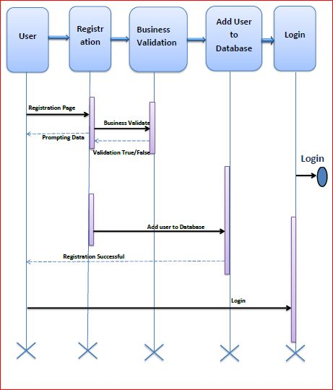

Business Rules
Business rules should be defined using the following attributes: -

- A registered user – is able click ‘Login’ link, after keying in ‘UserID’ & ‘Password’ field and get his credentials authenticated with the existing database entry.

UI Requirements
Here is a prototype on how the student registration should look like.

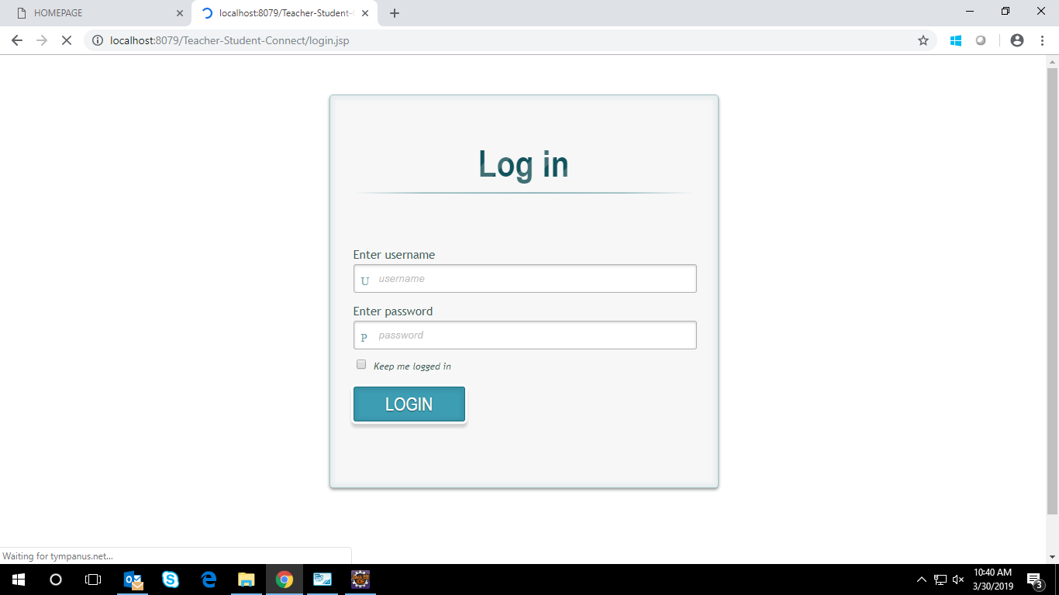

Database Design

Tables Structure
Student Registration:
Column Name | Data Type | Length | Nulls
First Name | Alphabetic | 50 | N
Last Name | Alphabetic | 50 | N
Email | Alphabetic | 50 | N
User-Id | Alphanumeric | 10 | N
Password | Alphanumeric | 15 | N

Student login:
Column Name | Data Type | Length | Nulls
User Id | nvarchar | 50 | N
Password | nvarchar | 50 | N

Admin Registration:
Column Name | Data Type | Length | Nulls
First Name | Alphabetic | 50 | N
Last Name | Alphabetic | 50 | N
Email | Alphabetic | 50 | N
User-Id | Alphanumeric | 10 | N
Password | Alphanumeric | 15 | N

Admin login:
Column Name | Data Type | Length | Nulls
User Id | nvarchar | 50 | N
Password | nvarchar | 50 | N

Examination:
Column Name | Data Type | Length | Nulls
Exam Id | Alphabetic | 20 | N
Exam Description | Alphabetic | 100 | N
Skill Set | Alphabetic | 20 | N
Competency Level | Alphabetic | 10 | N

Result:
Column Name | Data Type | Length | Nulls
User Id | Alphanumeric | 10 | N
Correct Answer | Numeric | 3 | N
Incorrect Answer | Numeric | 3 | N
Unattempted | Numeric | 3 | N
Total Questions | Numeric | 3 | N
Test Name | Alphanumeric | 20 | N

Question:
Column Name | Data Type | Length | Nulls
Question Id | Alphabetic | 10 | N
Question Creator | Alphanumeric | 15 | N
Question | Alphabetic | 500 | N
Choice | Alphabetic | 500 | N

Change Log
Version Number | Changes Made
V1.0 | Initial baseline created on <27/03/19> by Utkarsh Nagpal
V1.1 | <Please refer the configuration control tool / change item status form if the details of changes are maintained separately. If not, the template given below needs to be followed>
V1.1 | Section No. | Changed By | Effective Date | Changes Effected

